COMP 305 Full Stack Tutorial
Kai Laitinen

Setup and Install
You will need:
- Microsoft SQL Server Management Studio database
- An Express Microsoft SQL Server
- A GitHub account
- Microsoft Visual Studio
- Node.js
- Microsoft Visual Studio Code
- GitBash
All of which should be up to the latest versions, you can check to make sure they are in your installer(s). Microsoft Visual Studio should also have the ASP.NET packages installed with the initial installation.

SSMS: Install SQL Server Management Studio | Microsoft Learn
SSMS Server: SQL Server Downloads | Microsoft
MVS: Visual Studio: IDE and Code Editor for Software Development
Node.js: Node.js — Download Node.js®
VSC: Visual Studio Code - The open source AI code editor | Your home for multi-agent development
GitBash: Git - Install for Windows

If you have trouble downloading SSMS, a server, connection with the server (check Trust Server Certificate) and creating tables, look it up or use AI. This is a tutorial for the front end and back end basics.

Starting In Microsoft Visual Studio
IF YOU DID NOT INSTALL ASP.NET with your Microsoft Visual Studio, go back to your installer and do so.

In SSMS, make sure your table(s) has a primary key with identity (1,1) for the models we will be scaffolding.
We will be using this template for your project, if you cannot see it in your templates, scroll down, search and then check if you installed ASP.NET with your MVS.
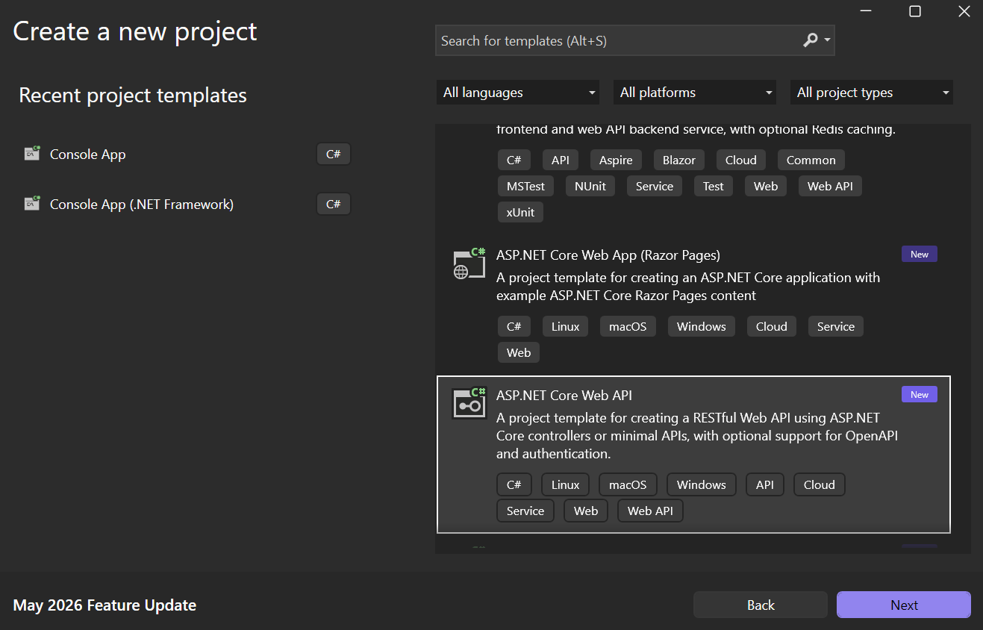

Create .NET Web API basic solution.

Back End
Basic back end with API endpoints in MVS
Open your Solution Explorer from View, it is vital for everything we will be doing.

Initial Test
Go to Properties and open launchsettings.json.
Change either the https or http profile to have “launchBrowser”: true and add “launchUrl”: “WeatherForecast”. If there is a problem in launching this, other than trusting localhost and Hot Reload, figure it out yourself, this is a learning opportunity. Otherwise, you should get this:
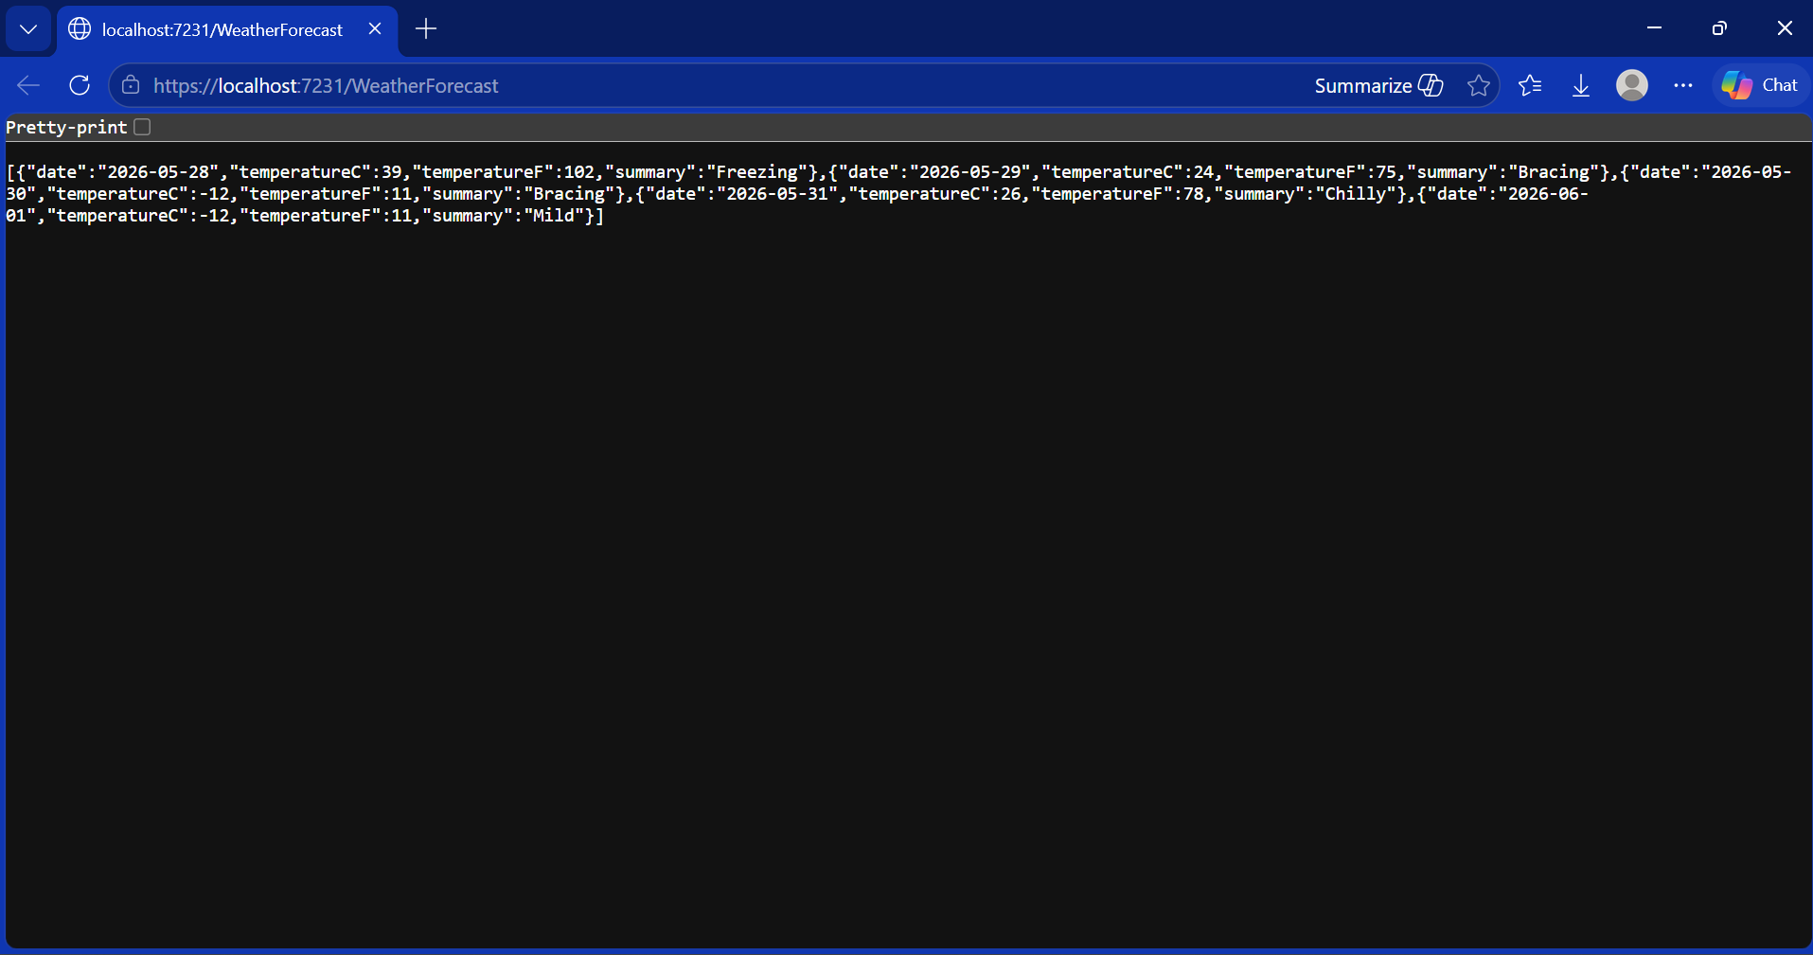

SQL Server
To connect a server, go to View=>SQL Server Object Explorer=>Add DB=>Browse=>Local=>(YOUR DB).
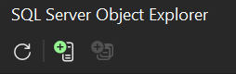
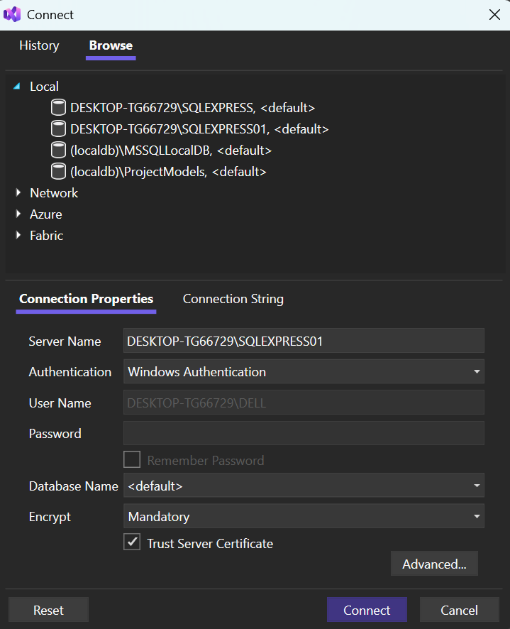

NuGet
Go to Project=>Manage NuGet Packages…=>Browse

Download STD Microsoft.EntityFrameworkCore packages. (.SqlServer, Tools, and Design)
Install the latest versions of each.

Put this string with your connection string into the Git package terminal in Tools=>NuGet Package Manager=>Package Manager Console:
Scaffold-DbContext “ConnectionString” Microsoft.EntityFrameworkCore.SqlServer
Your Connection string is in the SQL Server Object Explorer inside the properties of the server instance. But, you must add “Initial Catalog=DATABASENAME;” inside the connection string to specify your database inside the server.
This makes your models.

Connection String Setup
In appsettings.json add
“ConnectionStrings” : { “DefaultConnection” : “YourConnectionString”}
Make sure this is not inside “logging” of appsettings.json
In Program.cs add (before var app = builder.Build(); )
builder.Services.AddDbContext<YOUR_DB_CONTEXT_HERE>(options =>
options.UseSqlServer(builder.Configuration.GetConnectionString("DefaultConnection")));

And
using Microsoft.EntityFrameworkCore;
using <Solution>;
At the top, if they did not already appear.

RUN THE SOLUTION TO MAKE SURE IT WAS NOT BROKEN IN THE PROCESS

Controllers
We will now make a controller, starting with Controllers=>Add=>New Scaffolded Item=>API Controller with actions, using Entity Framework
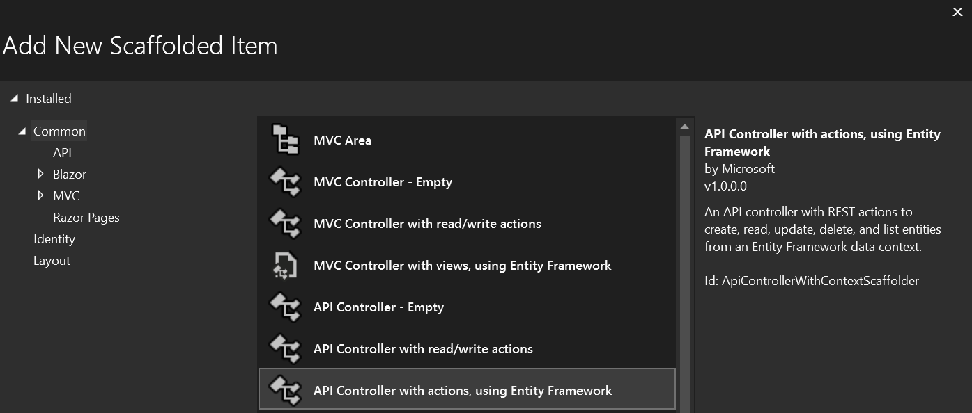
This should build out a controller for a table of your given scaffolded database.

We can now change the launchUrl to “api/Customer” (in this example) and run the solution to get this simple back end.

This should set everything up for you. Then go to launchSettings in Properties and change the launchUrl to “api/<table + s>”
Then go into program.cs and add using <NameOfSolution>
Running this should make a window appear with JSON data. This is how mine looks:
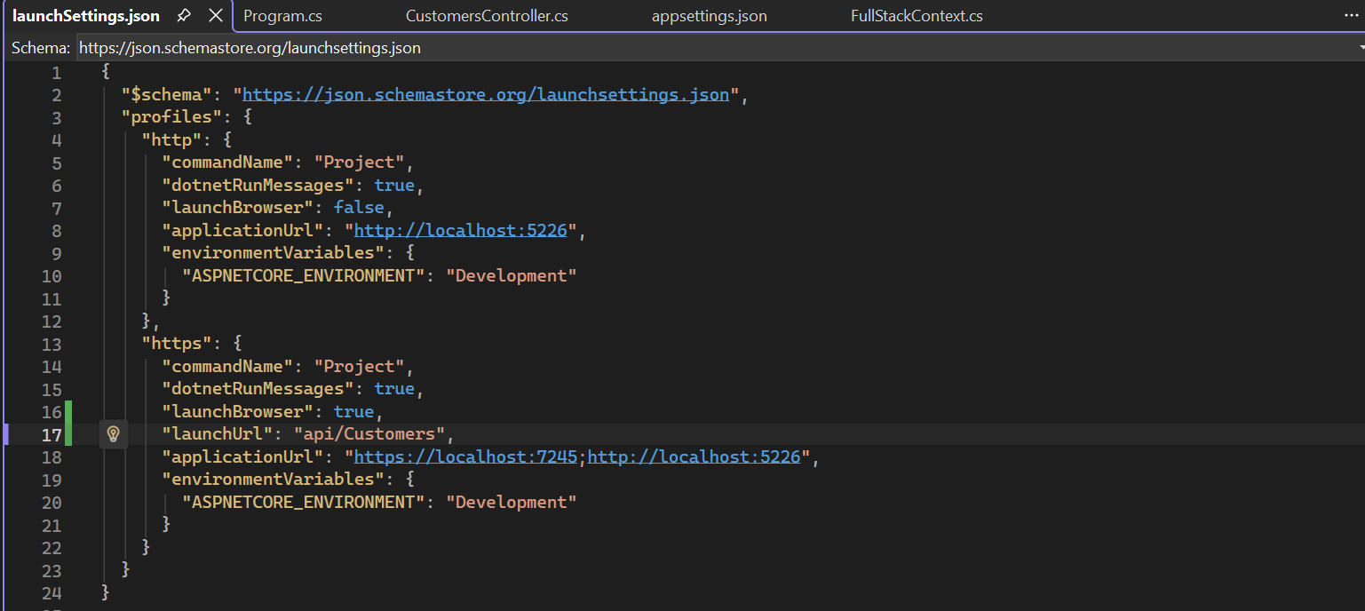
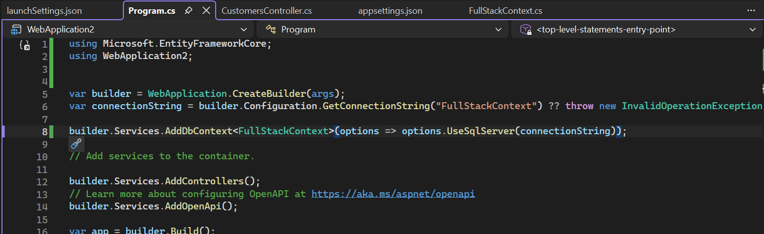
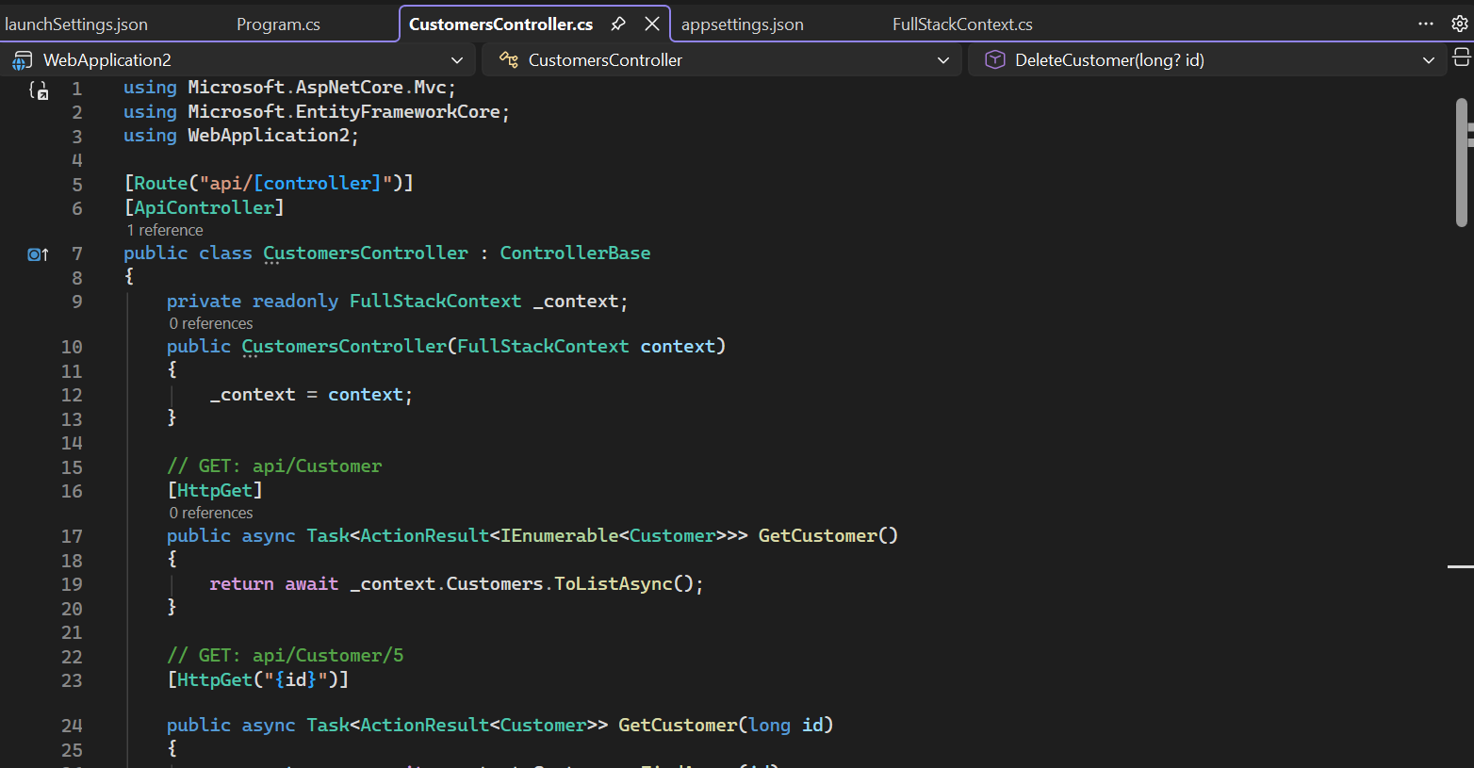
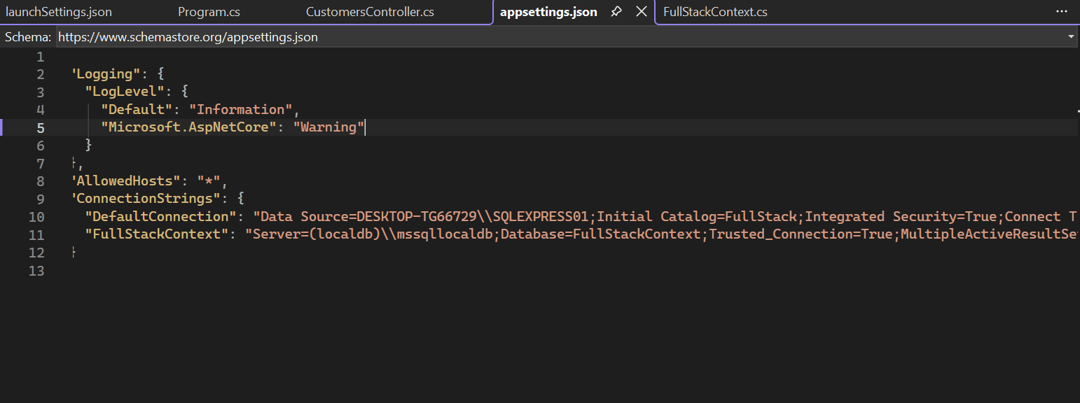
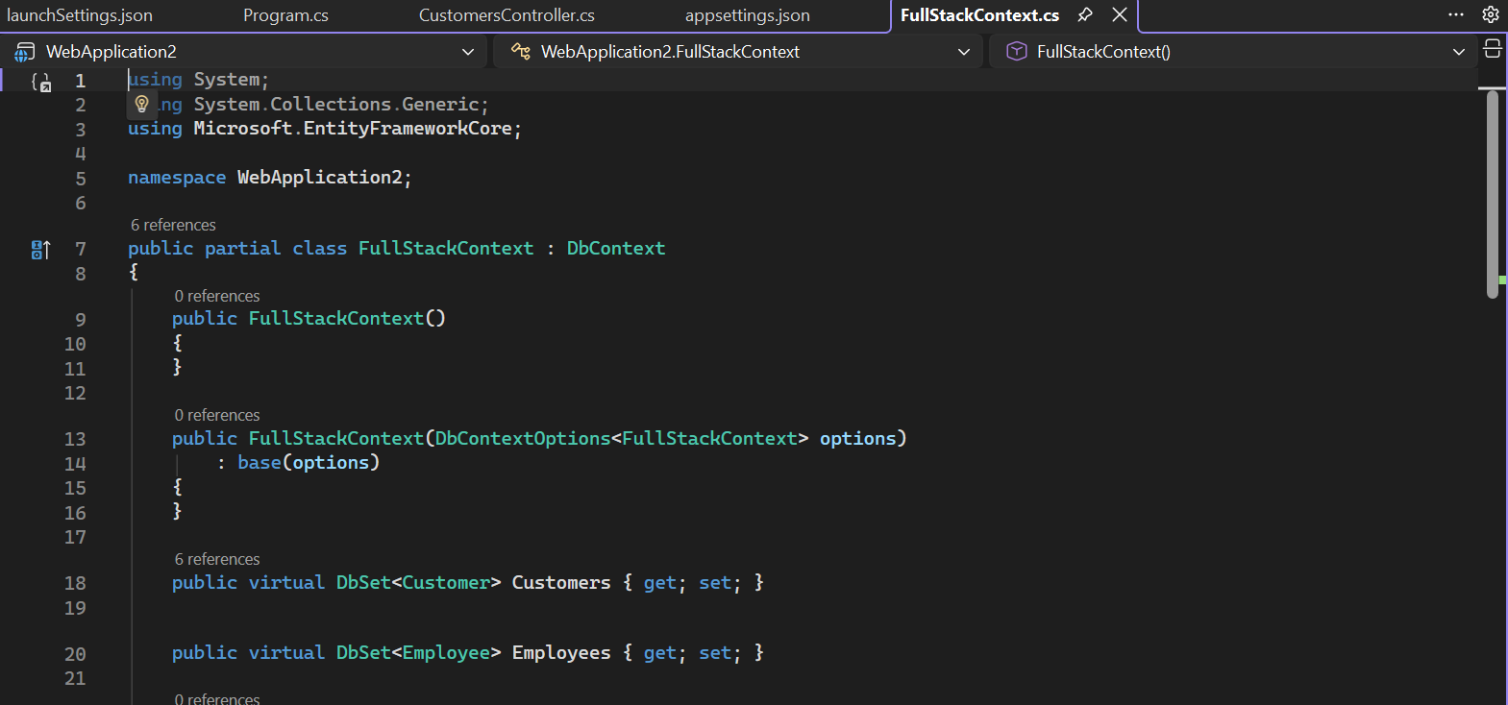

Front End
Basic back end in Visual Studio Code using Node.js
At this point it is essential to have everything from the Setup and Install section installed, as this is where it will all work together.
First we will make sure Node is installed and in VSC, go to the terminal and
node -v
npm -v
If there is an error, that is expected and next we will put
Set-ExecutionPolicy -Scope CurrentUser -ExecutionPolicy RemoteSigned
This gives us the ability to run commands in VSC so we can use
npx create-react-app my-frontend
This will create a react front end app with the name my-frontend (or whatever name you would like, I like app1)
Now use
cd my-frontend
code .
To Isolate VSC to just out frontend
Open src=>app.js and we will overhaul the app to make it our own
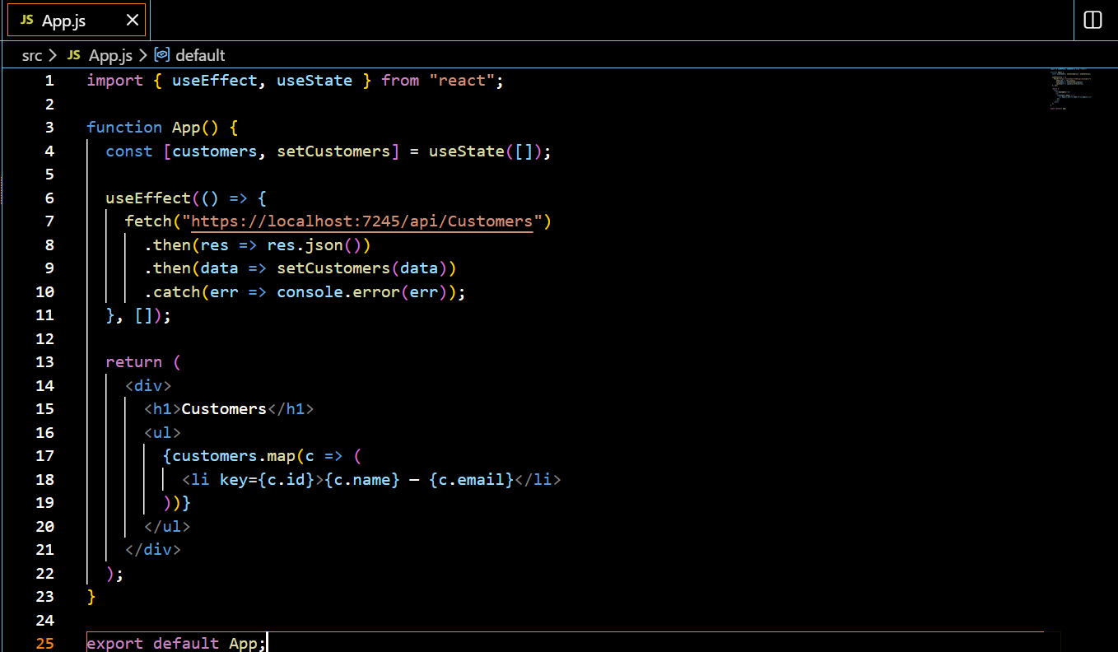

Now we return to MVS to add a way to connect to the backend via
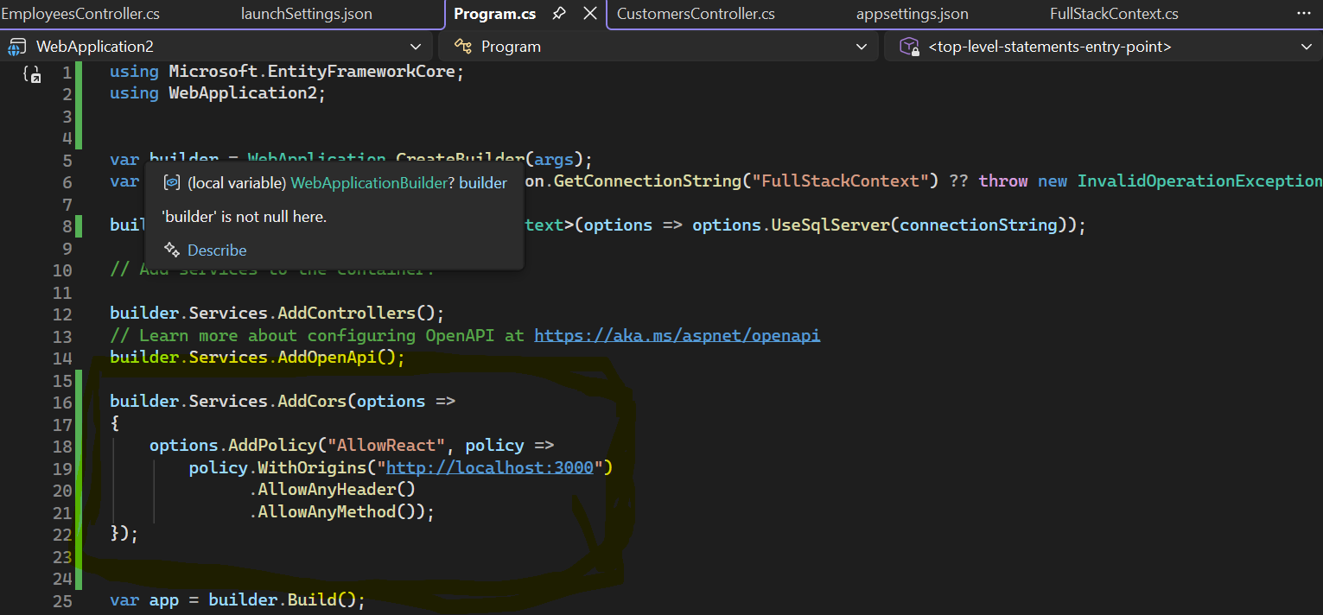
This must come before the app builder.

Then we add
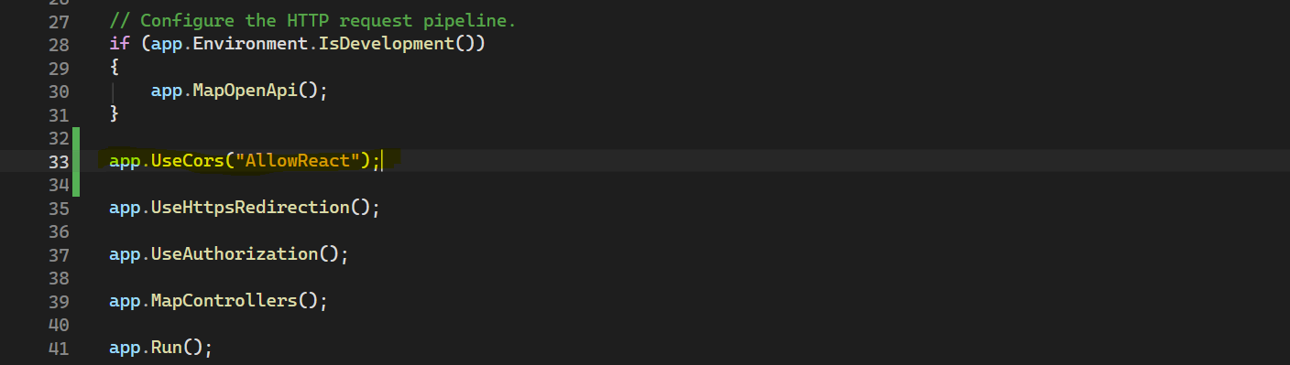
Before app.Run()

This creates a Cors policy to allow our specific frontend and then adds it to the backend app’s functions so the frontend is allowed to access it.

We can now run the backend with the run button is MVS and use npm start is VSC to get a quaint frontend of our database:
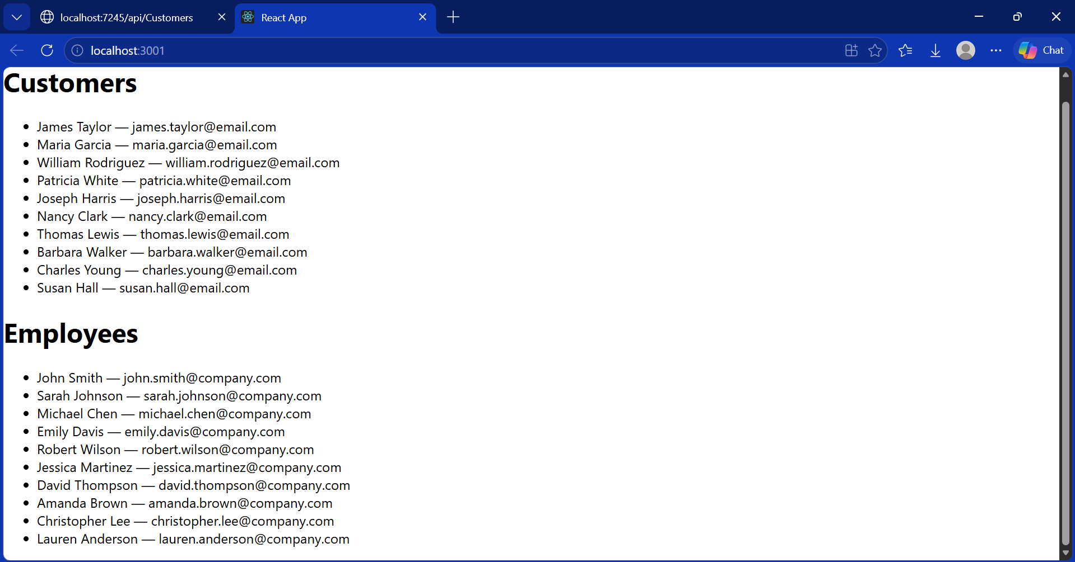
We now have a basic read function.

READ
Again, start the front end with
const getStudents= () => {
fetch(“https://localhost:####/api/Students)
.then(res => res.json())
.then(setApiData)
.catch(err => setError(err.message))
}

useEffect(() => { getStudents() }, [])

We now add a apiData.map for the App so we can see the Students:
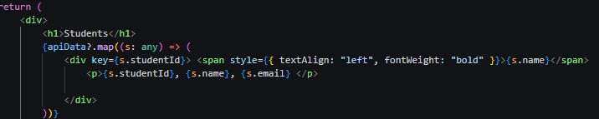
This sets us up to be able to access the data and also access the data for other CRUD functions.
This will let us have a way to check our database table, as well as recheck it after we change it with the other CRUD functions.

CREATE
For our first alternate CRUD function, create will be an example of how the front end uses the back end’s functions to change the database data.
The formula for these goes like this: fetch the basic backend, specify the method we are using, use the corresponding headers, then add any additional data into the body.
Like this:
const postStudent = () => {
fetch(FETCH, {
method: "POST",
headers: { "Content-Type": "application/json" },
body: JSON.stringify({ name: newName, email: newEmail }) })
.then(() => { setNewName(""); setNewEmail(""); getStudents() })
.catch(err => setError(err.message))
}
This effectively passes the variables for the POST back end function.

Now we must add it to our front end App. For this we will add input sections and then a button to execute the post function.
Here is what we have added for postStudent.

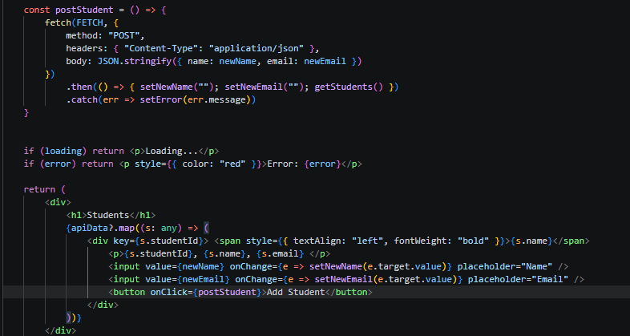
Correction: the inputs should be outside the second level of <div></div> so it shows up after instead of on each one.

UPDATE
This uses the same formula as the create but it requires an id input as well.
const putStudent = (id: number) => {
fetch(`${FETCH}/${id}`, {
method: "PUT",
headers: { "Content-Type": "application/json" },
body: JSON.stringify({ name: editName, email: editEmail })
})
.then(() => { setEditId(null); setEditName(""); setEditEmail(""); getStudents()})
.catch(err => setError(err.message))
}

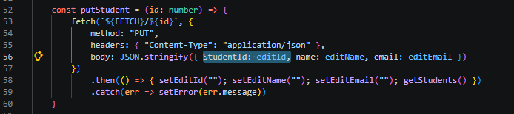
Very key to match the names of the model in MVS to the variables you pass here, or else the update will not work.

DELETE

const deleteStudent = (id: number) => {
fetch(`${FETCH}/${id}`, {
method: "DELETE"
})
.then(() => getStudents())
.catch(err => setError(err.message))
}

Final App
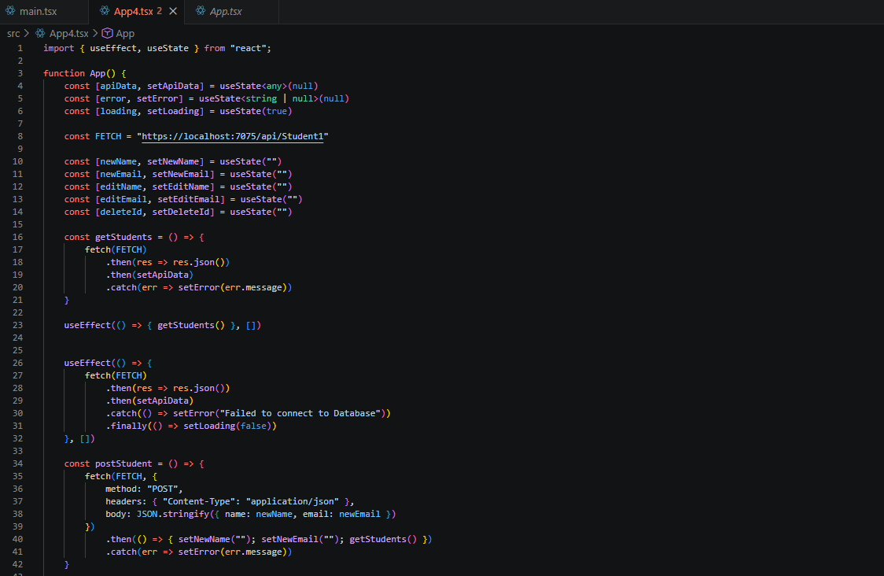
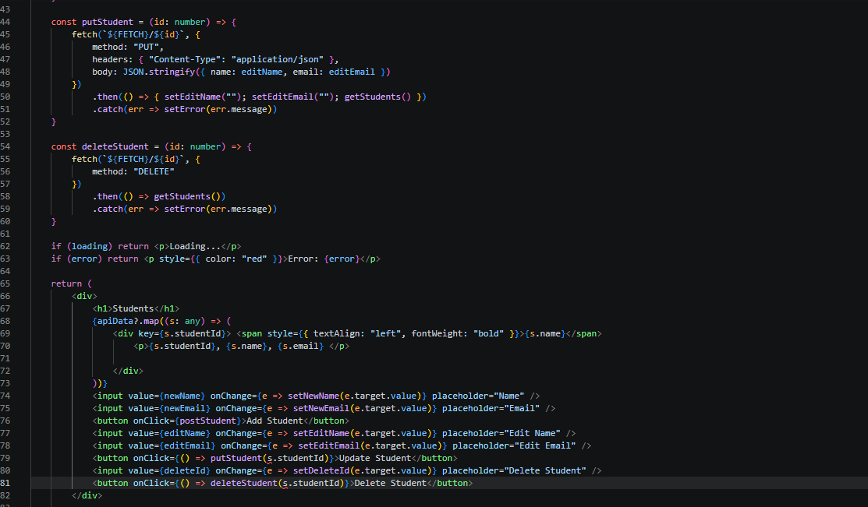

GIT:
Using Git is very simple.

Install Git Bash.

Create a Git Repository using a free GitHub account, then copy the link for it and follow these commands in your terminal (at the correct file location ex: C:Users\klaitinen\.vscode\app1):

git init
git remote add origin <paste link>
git branch -M main
git add .
git commit -m “initialize”
git push -origin main

And then you will have a git repository of whichever folder you were on.
Use:

cd .. to go back a level
dir to see the files in the current level
cd <file name> to navigate down

Or just use the open in terminal function from your file explorer to get to the proper file.
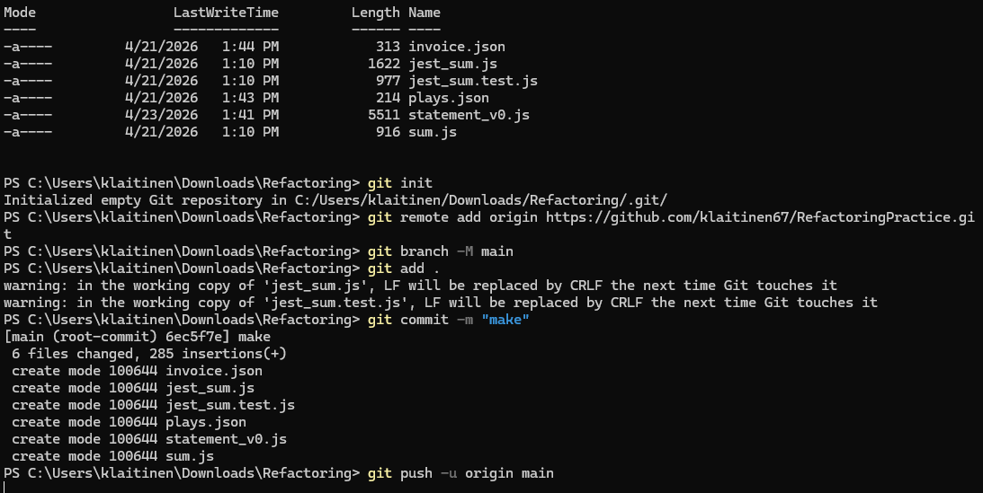

Updating the GitHub Repo is as simple as
git add .
git commit -m “message”
git push

And the current version will be added into the repository’s history

